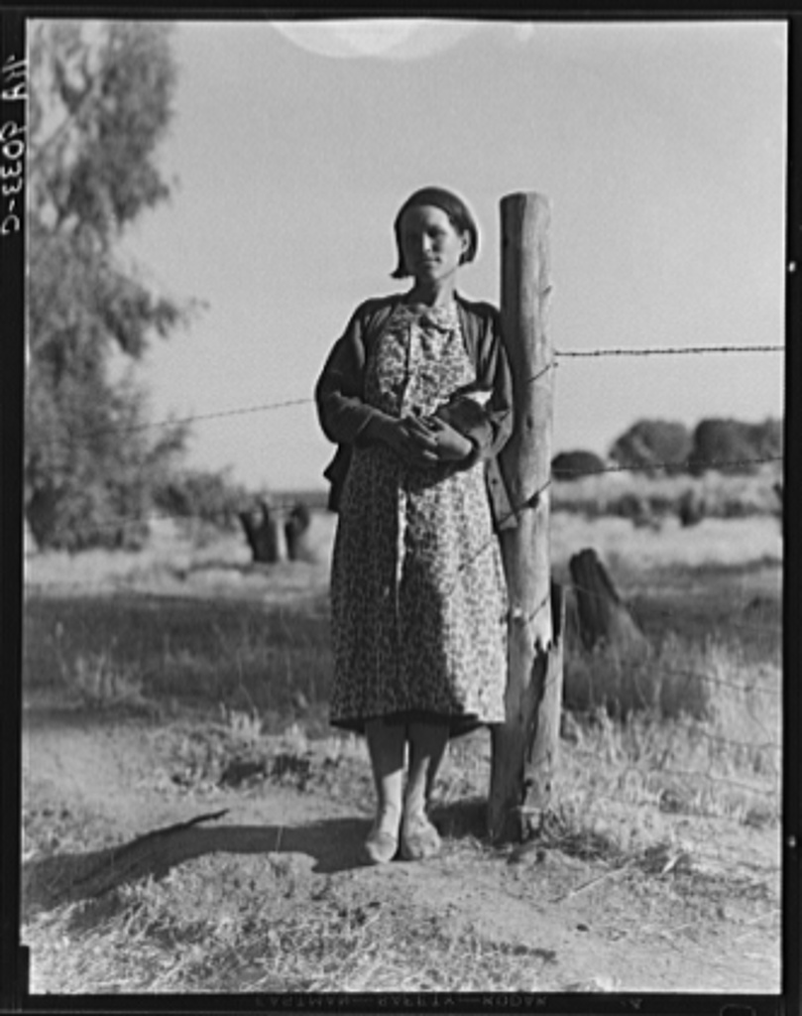 | The Grapes of Wrath  Expert Discussion Leader Assessment Project  ______ points  My Due Date: ______ | 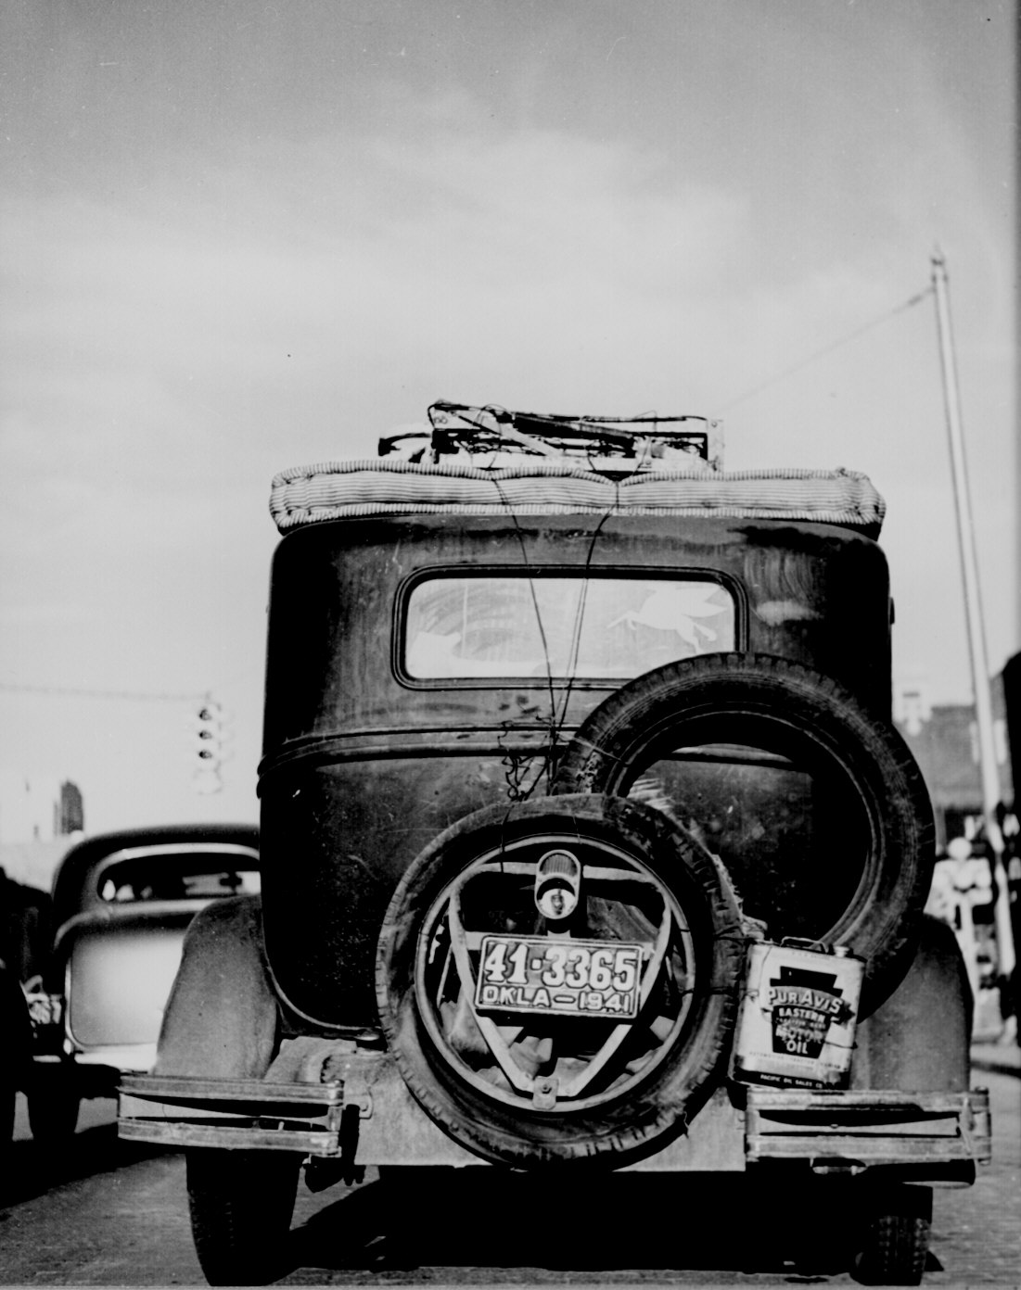
Purpose: Demonstrate your mastery of the text by teaching its crucial elements to your peers.
Result: Your peers will have a completed right and left side in their notebooks. They will turn to you, as the expert, to answer questions or to clarify the text. Your classmates will also have the opportunity to interact with the text in two different ways designed by you.
LEFT SIDE (summary + reflection) | RIGHT SIDE (interpretation/synthesis)
Summary: Students will take notes from your comic strip (hand-drawn or computer generated), illustrated timeline, or GoAnimate presentation. Your summary must include information from both chapters. Students will record FIVE key events using jot notes.  KEY EVENTS  1.  2.  3.  4.  5. | Creative Interpretation: Choose 1-2 options from the list below OR get approval for an innovative interpretation of your own. All work should cover this page and must be printed out for your classmates (portions deliberately blank) and the teacher (no blanks). You will help the class fill in the blanks.  Graphic Organizer or Infographic: The class will receive a copy of your graphic organizer or a printout of your infographic.  T-shirt or Poster: Create a design that incorporates one quote and an image. Provide a brief description (3-4 sentences) of why your quote is pertinent. Students will receive a copy of your design.  Song: Write your own song or rewrite a song. Be prepared to sing (no points lost for being bad singing) your song. Students will receive a copy of your lyrics.  Interview: Write a script for an interview and videotape it. Play your video or perform your interview live for the class. Students will receive a copy of your script.
What? So What? Now What?: The class will check their understanding of your work by completing this section on their own.

What? = 1 sentence
What happened? Very simply, describe the gist of the chapters.

So What? = 1-4 sentences
What does it matter? What was the author trying to show/explain in these chapters. Can you identify a theme (big idea) or a message for the world?

Now What? = 1-2 sentences.
What does it mean for the future -or- for me? Make a prediction or make a connection (Text-Self, Text-Text, or Text-World).
Method:
- WORK with a partner. Decide how much you want to work together. You may collaborate on everything or divide the work evenly. Each person will receive a personal grade.
- SELECT two consecutive chapters (interchapter and regular chapter) to illuminate. CHECK your calendar to be sure you can present on the chosen date. If there is a schedule conflict, switch with someone (you may need to bribe them).
- DRAW a comic strip/illustrated timeline (try a Storyboardthat student account from the teacher) or MAKE a GoAnimate presentation (again, get a student account from your teacher) showing the FIVE key events of your chapters. Do not write a summary, provide jot notes, or list events. You can split the summary in any way that makes sense, but you must have at least one key event from each chapter.
- COMPLETE a creative interpretation or analysis of both chapters.If you have a creative new idea, get it approved by the teacher. You will provide your classmates with a printout of your work for everyone in the class. The student copies will have 5-10 spaces left blank for individual words or phrases (no more than 3 words together) that they will have to fill in during your presentation. Do not leave blanks for entire sentences. Print out 2 completed versions of your work (1 for you to use and 1 for the teacher).

SUGGESTED RESOURCES

Graphic Organizer: Draw your own or try downloading an organizer from thinkport.

Infographic: Try the free infographic templates at Piktochart.

T-shirt: Draw your own front and back designs (remember you need at least 1 quote and at least 1 image). Look online for element placement ideas (where to put the quote or image), but don’t accidently order a design package. Use your art or graphic design background (or get help from one of your teachers) for this task.

Poster: Draw your own design (remember you need at least 1 quote and at least 1 image) or try an online service like Smore or Piktochart.

Song: Use GoogleDocs or Microsoft Word. If you rewrite a song, you should provide the original lyrics and the new lyrics. It’s easy! Just put a 2-column table in your document with the original on one side and the new version on the other side. You may sing live or record yourself using iMovie to present.

Interview: Use GoogleDocs or Microsoft Word for the script. Use iMovie to record your interview. You can either show the video in class or perform your interview live for the class.

- MEET with your teacher to check your technology and materials the day before your presentation.
- PRESENT your findings to the class and lead the discussion as the expert. TURN IN all work for the class binder.
Class Calendar (Maroon and Silver Day Block Schedule)
Monday | Tuesday | Wednesday | Thursday | Friday
Mar. 21  Assessment Intro  Sign-up | Mar. 22  Assessment Intro  Sign-up | Mar. 23  Work day | Mar. 24  Work day | Mar. 25 (Ch 1-4)  1-2 __________________________  3-4  __________________________
Mar. 28 (Ch 1-4)  1-2 __________________________  3-4  __________________________ | Mar. 29 (Ch 5-8)  5-6 __________________________  7-8  __________________________ | Mar. 30 (Ch 9-12)  9-10  __________________________  11-12  __________________________ | Mar. 31 (Ch 9-12)  9-10  __________________________  11-12  __________________________ | Apr. 1 (Ch 13-16)  13-14  __________________________  15-16  __________________________
←←← BREAK →→→
Apr. 11 (Ch 13-16)  13-14  __________________________  15-16  __________________________ | Apr. 12 (Ch 17-20)  17-18  __________________________  19-20  __________________________ | Apr. 13(Ch 21-24)  21-22  __________________________  23-24  __________________________ | Apr. 14(Ch 21-24)  21-22  __________________________  23-24  __________________________ | Apr. 15(Ch 25-28)  25-26  __________________________  27-28  __________________________
Apr. 18 (Ch 25-28)  25-26  __________________________  27-28  __________________________ | Apr. 19 (Ch 29-30)  29-30  __________________________  Makeups  __________________________ | Apr. 20(Ch 29-30)  29-30  __________________________  Makeups  __________________________ | Apr. 21 | Apr. 22

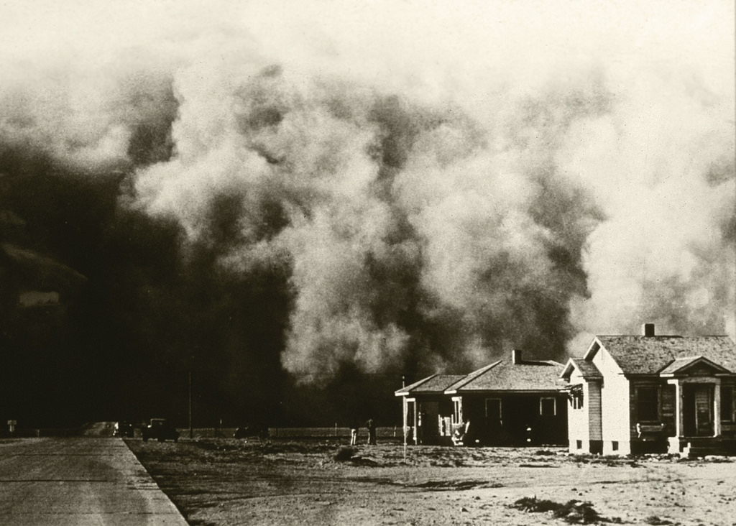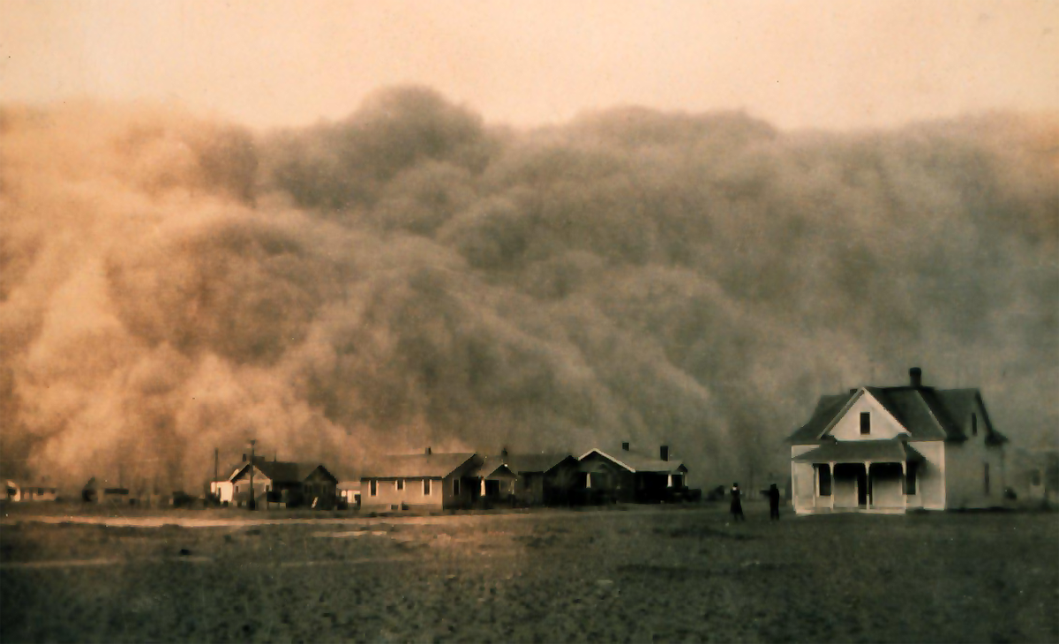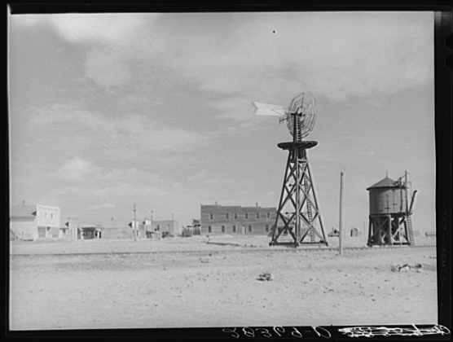
Approximate page ranges for chapters. Your edition may have different pages.
Chapters | Approximate Pages | Chapters | Approximate Pages
1-2 | 1-13 | 17-18 | 193-230
3-4 | 14-30 | 19-20 | 231-281
5-6 | 31-60 | 21-22 | 282-324
7-8 | 61-85 | 23-24 | 325-345
9-10 | 86-114 | 25-26 | 346-405
11-12 | 115-122 | 27-28 | 406-431
13-14 | 123-152 | 29-30 | 432-455
15-16 | 153-192

Graphic Organizer Ideas
Star: If the topic involves investigating attributes associated with a single topic, use a star diagram as your graphic organizer. Example: Finding methods that help your study skills (like taking notes, reading, doing homework, memorizing, etc.).

Spider: If the topic involves investigating attributes associated with a single topic, and then obtaining more details on each of these ideas, use a spider diagram as your graphic organizer. This is like the star graphic organizer with one more level of detail. Example: Finding methods that help your study skills (like taking notes, reading, memorizing, etc.), and investigating the factors involved in performing each of the methods.

Fishbone: If the topic involves investigating multiple cause-and-effect factors associated with a complex topic and how they inter-relate, use a fishbone diagram as your graphic organizer. Example: Examining the effects of improved farming methods.

Cloud/Cluster: If the topic involves generating a web of ideas based on a stimulus topic, use a clustering diagram as your graphic organizer. Example: brainstorming.

Tree: If the topic involves a chain of events with a beginning and with multiple outcomes at each node (like a family tree), use a tree as your graphic organizer. Example: Displaying the probabilistic results of tossing coins.

Cycle of Events: If the topic involves a recurring cycle of events, with no beginning and no end, use a cyclic graphic organizer. Example topic: Documenting the stages in the lifecycle of an animal.

Flowchart: If the topic involves a chain of instructions to follow, with a beginning and multiple possible outcomes at some node, with rules at some nodes, use a flowchart. Example: Computer programmers sometimes use flowcharts to organize the algorithm before writing a program.

Venn Diagram: If the task involves examining the similarities and differences between two or three items, use a Venn diagram. Example: Examining the similarities and differences between fish and whales, or comparing a book and the accompanying movie.

T-Chart Diagram: If the task involves analyzing or comparing with two aspects of the topic, use a T-Chart. Example: Fill out a T-Chart to evaluate the pros and cons associated with a decision.

Fact/Opinion: If the task involves distinguishing the facts vs. the opinions in a theme or text, use fact/opinion charts. Example: Fill out a fact/opinion chart to evaluate the facts and opinions presented in a news article.

Decision Making Diagrams: If the task is making a decision, use a graphic organizer to enumerate possible alternatives and the pros and cons of each. Example: Fill out a desicion making diagram to help decide which elective courses you'd like to take next quarter.

Cause and Effect Diagrams: If the task is examining possible causes and effects in a process, use a cause and effect graphic organizer . Example: Fill out a cause-and-effect diagram to trace the steps in a feedback loop.

Pie Charts: If the task involves showing divisions within a group, use a pie chart. Example: Draw a pie chart to show what percentages of a population have blue eyes, green eyes, or brown eyes.

Character Traits: Graphic organizers help the student identify the traits of fictional characters by looking at events surrounding the character in the text.

Prepared by Nikki Tobias, 2016 Steinbeck Institute

